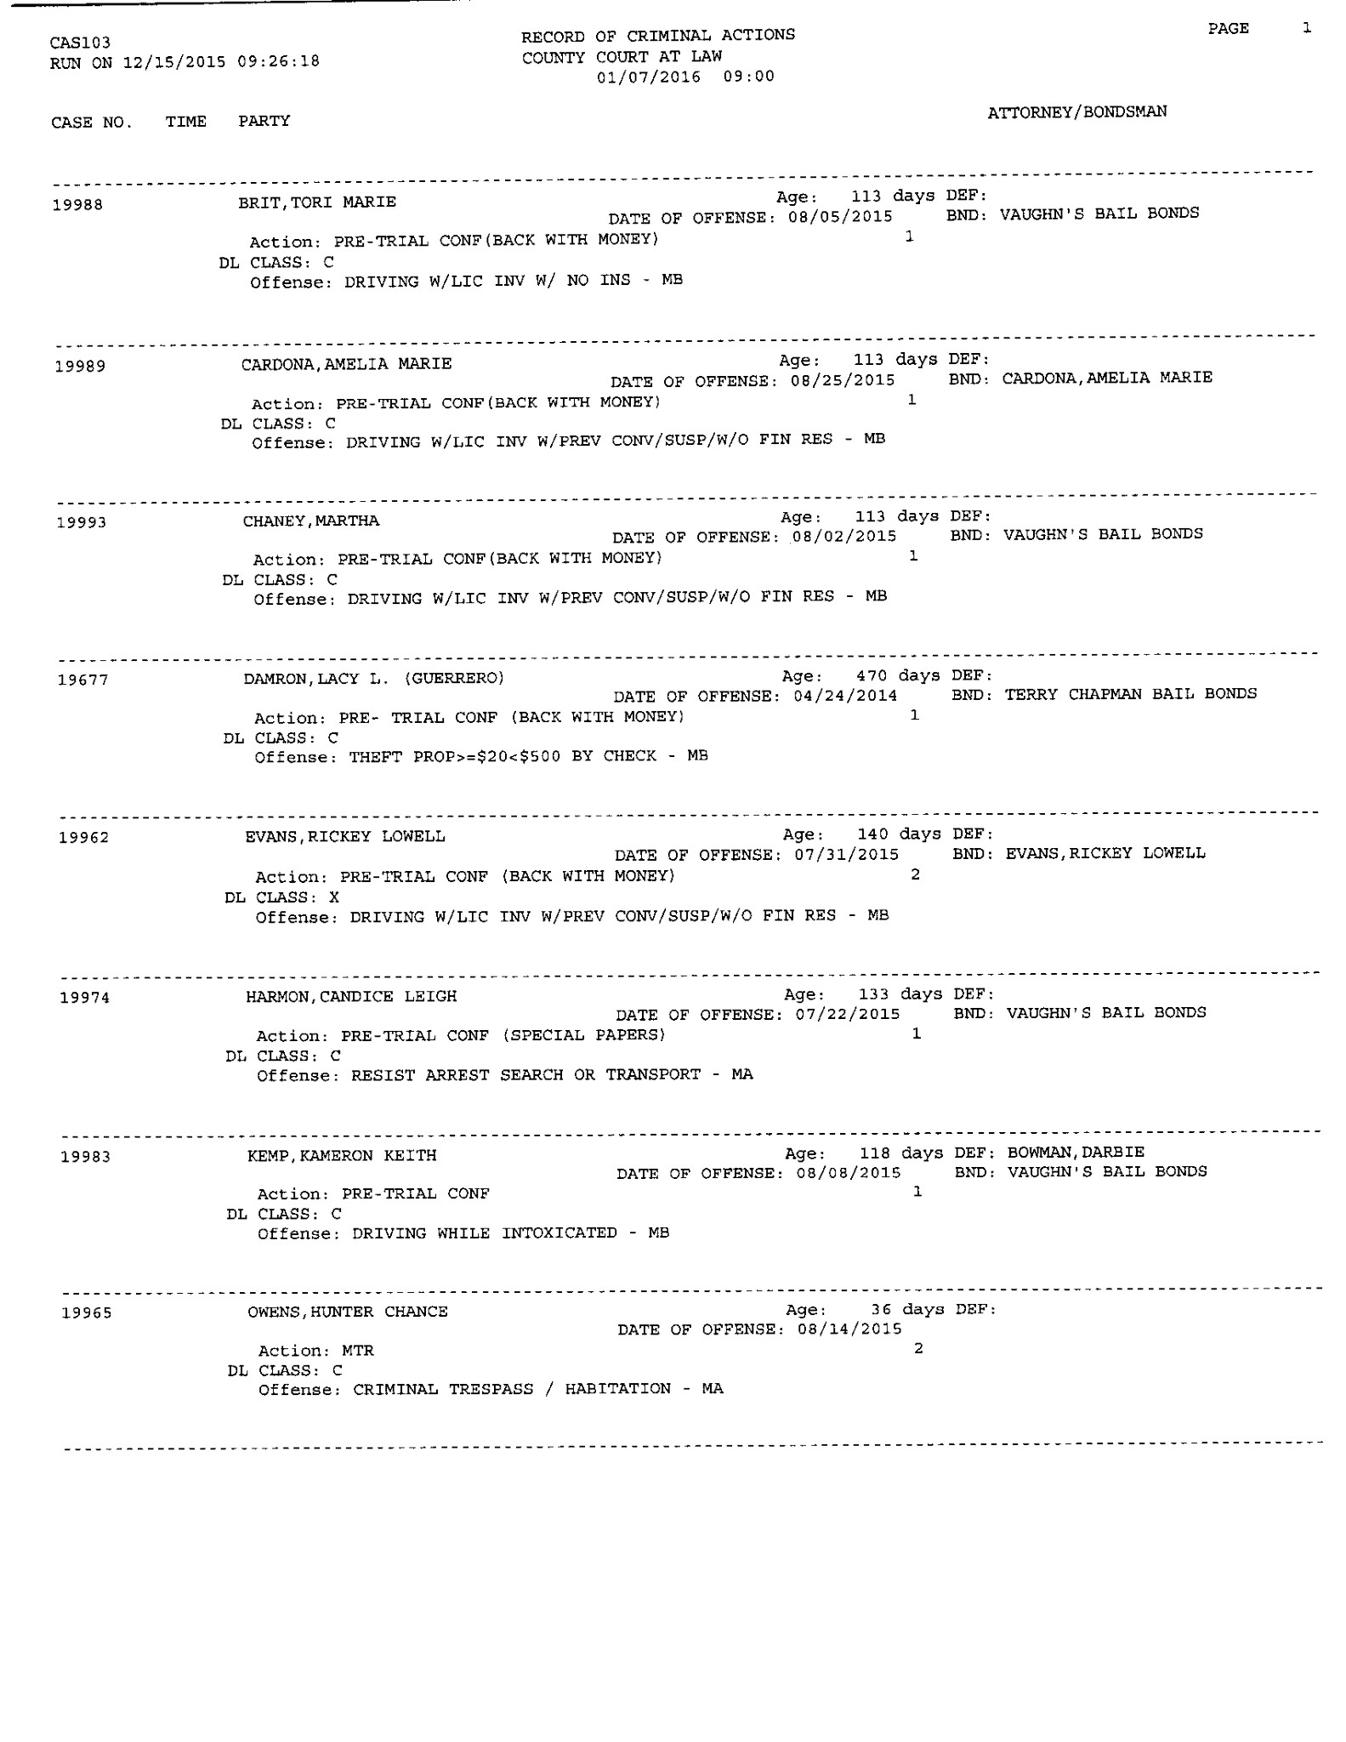

PRE-TRIAL CONF 1/7/16

Trial 2/22/16

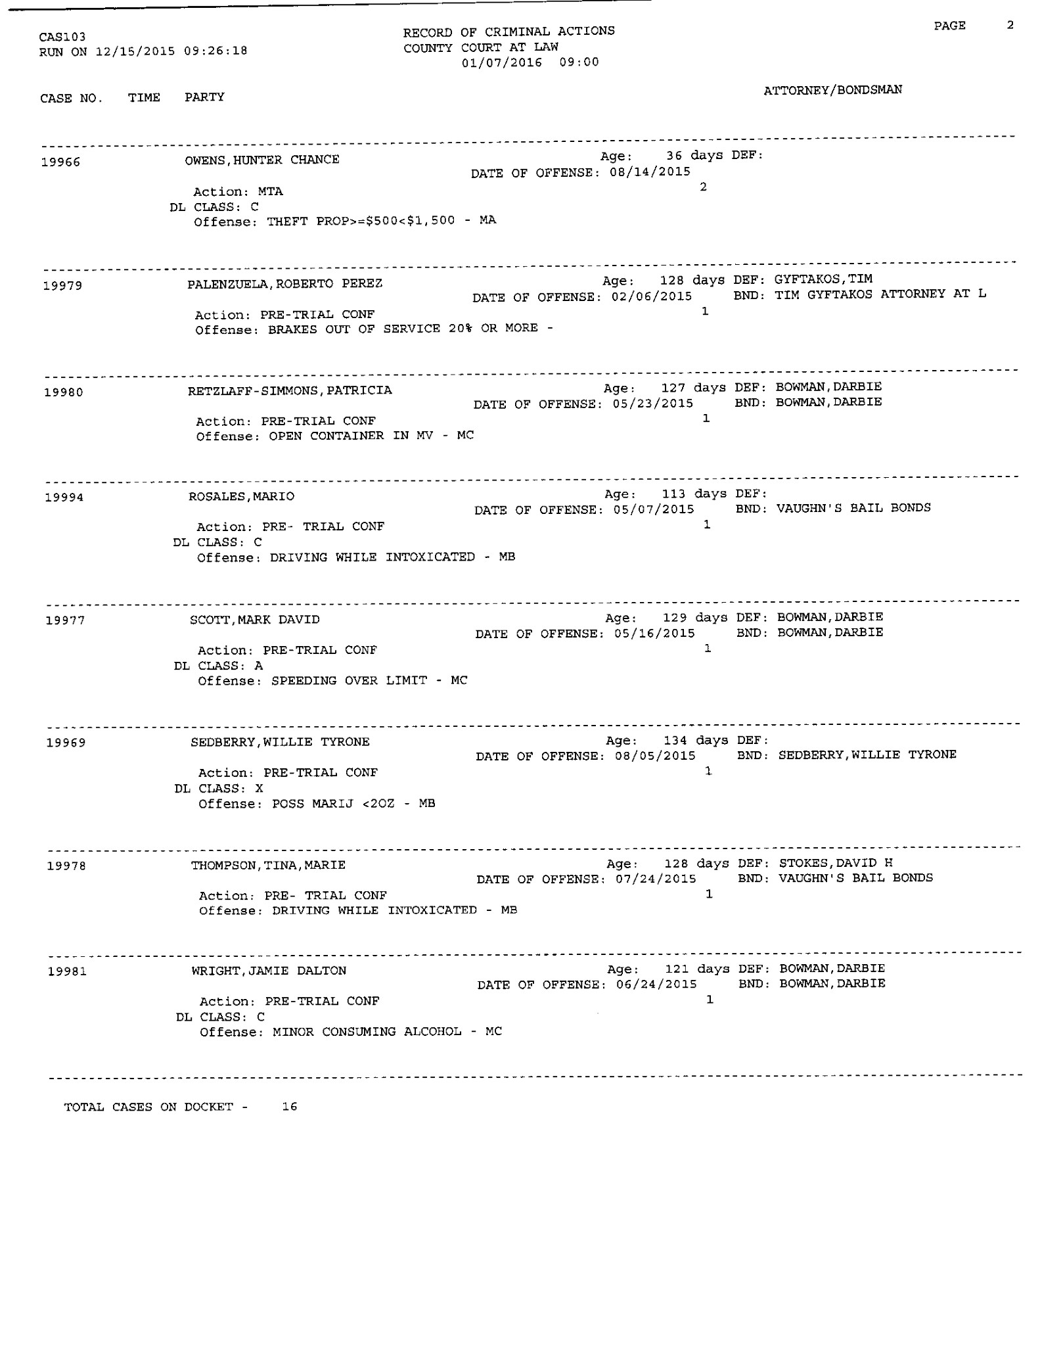

Pre-Trial 1/7/16 @ 1:00

Pre-trial conf 2/11/16 @ 9:00

Trial 3/17/16 @ 9:00

